Colonial Database ERD

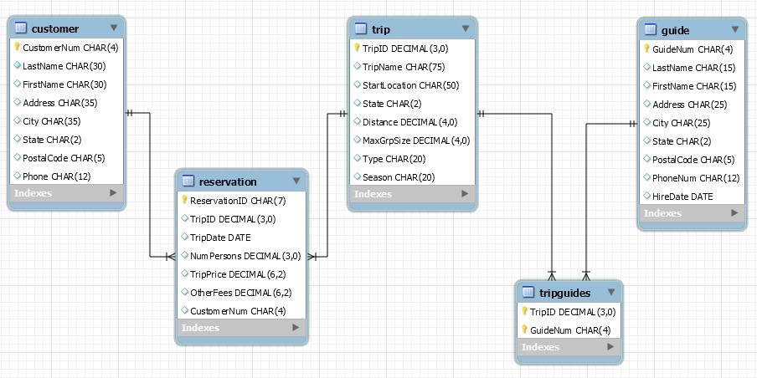

Accounts Payable Database ERD

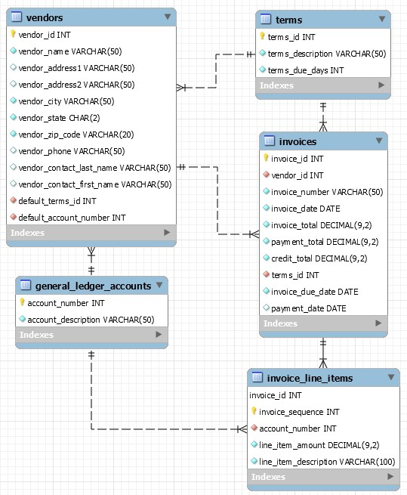

Prestige Cars Database ERD

